UNITED STATES MILITARY ACADEMY

FINAL REPORT ARIBO-IH

XE402: INTEGRATIVE SYSTEM DESIGN

SECTION I1

COL SHAY

LTC MAYMI

BY

CADET MATTHEW ABREU, CO B4

CADET MICHAEL ANDERSON, CO D2

CADET MICHAEL CARR, CO C2

CADET MATTHEW CARROLL, CO C4

CADET CRAIG FENTRESS, CO E4

CADET VICTOR LOWE, CO H2

CADET JONATHAN ROMAN, CO I3

WEST POINT, NEW YORK

05 MAY 2014

_____ MY DOCUMENTATION IDENTIFIES ALL SOURCES USED AND ASSISTANCE RECEIVED IN COMPLETING THIS ASSIGNMENT.

_____ NO SOURCES WERE USED OR ASSISTANCE RECEIVED IN COMPLETING THIS ASSIGNMENT.

SIGNATURE: ____________________________________________

ARIBO-IH

Team Members: CDTs Michael Anderson, Michael Carr, Victor Lowe, Matthew Carroll, Craig Fentress, Matt Abreu, and Jonathan Roman

Advisor: LTC Paul Maxwell

**Abstract**

The purpose of the Applied Robotics for Installation and Base Operations – Industrial Hygiene (ARIBO-IH) project is to demonstrate the potential capabilities of an unmanned robot to the future of industrial hygiene. Team ARIBO-IH will eliminate unnecessary human exposure to potentially dangerous chemical, biological, radiological and nuclear (CBRN) environments by attaching gas, temperature, and humidity sensors to a PackBot chassis in order to remotely report environment statistics. The first year of this multi-year project is to provide proof of concept.

The ARIBO-IH PackBot features carbon monoxide, hydrogen, liquefied petroleum gas, methane, temperature, and humidity sensors. These sensors, along with onboard microcontrollers, are enclosed in water-resistant containers to prevent contamination of hardware and allow for decontamination procedures. All sensor data is integrated into the PackBot Operator Control Unit (OCU) and the PackBot and sensor package can operate up to two hours without replacing batteries. The outcomes of this project will consist of a modular sensor package that enables the user to select sensors they want to use, scalable data packet structure for future years, microcontroller-processed sensor data, power supplied to sensor package and microcontroller via PackBot battery system, and a database that stores the CBRN event’s sensor readings.

**Problem Statement**

Team ARIBO-IH will eliminate unnecessary human exposure to potentially hazardous CBRN environments by affixing chemical sensors to a PackBot chassis in order to remotely monitor chemical concentrations in the environment.

**Concept Sketch**

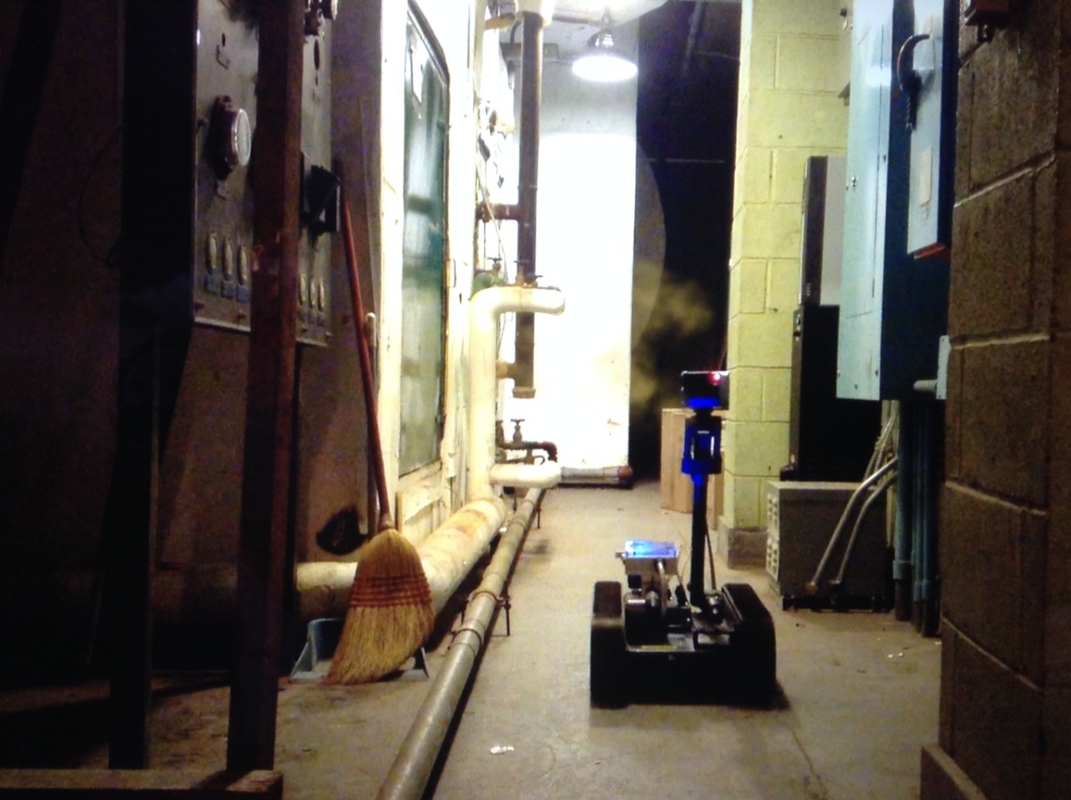

Figure 1: The Prototype at work in a fictional gas leak scenario

The ARIBO-IH will ideally be employed in industrial hygiene situations in order to determine the concentration of various CBRN threats in the environment. This may initially be restricted to military installations and civilian work environments that deal with hazardous materials.This could also extend to employment in combat situations that may be exposed to various CBRN threats. Provided the PackBot is outfitted with the necessary sensors, it could be used to detect chemical threats in the combat zone or in building clearing. iRobot has already developed a CBRN package for the PackBot. This package enables the robot to sense toxic industrial materials, chemical warfare agents, and radiation or explosive hazards and also includes visual and audible detection. While this modular CBRNe package is applicable for the army, it does not meet the Army’s specifications and it is not as cost effective as developing our own open source chemical package.

**Specifications**

The specifications for the ARIBO-IH consist of three requirements: interface, functional, and performance requirements. The interface consisted of connecting a gas sensor package to a microcontroller. Our solution to this specification used an Ethernet connection, connecting the microcontroller to the Packbot via 40 pin ribbon cable provided with the PackBot, and connecting the PackBot to the OCU via 4.9 GHz radio. The functional requirements were to create a sensor package that could interface with the PackBot and to create a data capture system that could capture and record sensor data. Finally, the performance requirements for the ARIBO-IH were for the robot to detect several hazards to human health, to be able to operate in an indoor environment, to operate with sensors up to 2 hours without replacing batteries, and to be water-resistant for moist environments and decontamination.

**Block Diagram**

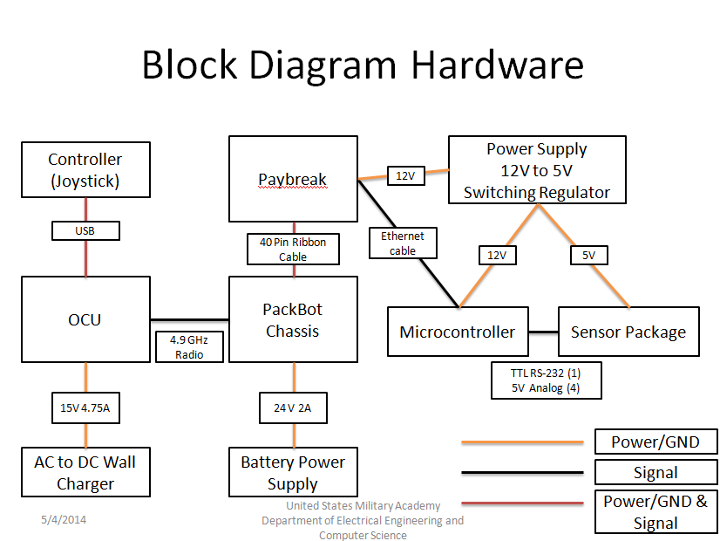

Figure 2: Block Diagram for Hardware

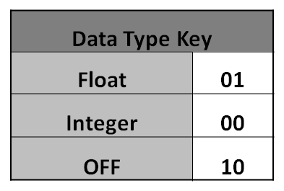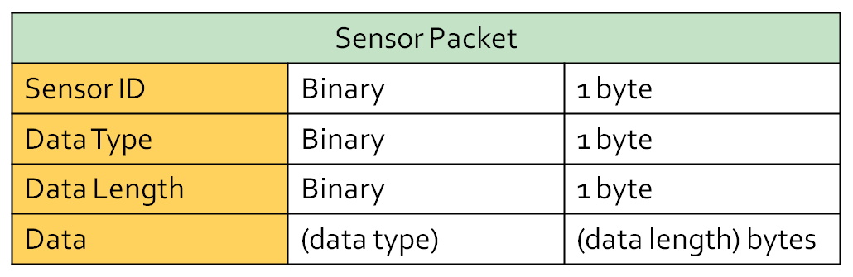Figure 3: Block Diagram for Software

Figure 4: Sensor Packet Structure

**Results**

Since the gas sensors are inherently inaccurate due to their cheap construction and intended use for small projects, each sensor had to be calibrated by graphing the output of each sensor compared to the known gas in the testing environment. For the testing environments we used 1.0 liter sealed containers with the sensor inserted into one end and a septum for needles inserted in the other as illustrated by Figure 5. The 1.0 liter volume made calculating parts-per-million (ppm) simple and gas was introduced to the environment via a syringe and needle.

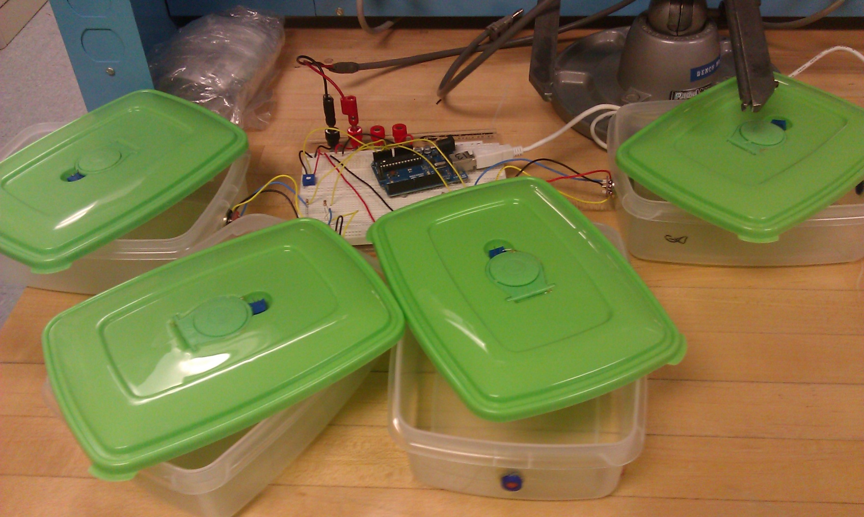

Figure 5: Testing environments for the (from left to right) MQ-4, MQ-6, MQ-7, and MQ-8 sensors.

By comparing the sensor output (x-axis) to the known concentration of gas in the testing environment (y-axis) a curve is formed, which can be best fit to an exponential curve by focusing the comparison on moderately to severely dangerous gas concentrations, which is approximately 2,000 to 10,000 ppm. The best fit equation for the most accurate test is used in the code for the Arduino to correct the sensor output to the most accurate output for transmission to the OCU. Figure 6 displays the graph for the MQ-4 (Methane) sensor and the graphs for the MQ-6 (Liquefied Petroleum Gas), MQ-7 (Carbon Monoxide), and MQ-8 (Hydrogen) sensors are detailed in Annex 3, Figures 13 – 15 respectively.

Figure 6: Sensor Output vs. Gas Concentration for MQ-4 Sensor

Using the correction equations in the code with the given sensor outputs, the final results fairly closely match the expected concentrations. Granted they are not extremely accurate, but the corrected outputs will be able to discern the difference between a safe and a dangerous environment. Table 1 details the MQ-4 sensor results and the results for the MQ-6, MQ-7, and MQ-8 are detailed in Annex 4, Tables 2 – 4 respectively.

|  |  |  |  |
| --- | --- | --- | --- |
| **Test 2 - 30 min preheat** |  |  |  |
| **Gas Concentration (ppm)** | **Output (stable)** | **Gas** |  |
| 0 | 126 | 0 |  |
| 1000 | 555 | 1000 | **Lethal** |
| 2000 | 638 | 2000 | 1956.147 |
| 3000 | 686 | 3000 | 3131.0761 |
| 4000 | 717 | 4000 | 4242.6019 |
| 5000 | 741 | 5000 | 5367.5778 |
| 6000 | 759 | 6000 | 6403.0647 |
| 7000 | 773 | 7000 | 7344.6837 |
| 8000 | 785 | 8000 | 8261.2569 |
| 9000 | 794 | 9000 | 9022.9988 |
| 10000 | 803 | 10000 | 9854.9783 |

Table 1: Known gas concentration compared to uncorrected stable output and final output for lethal range of concentration for MQ-4 sensor.

The power subsystem built into the package includes a switching regulator to step down 12V from the PayBreak interface chip into 5V to be used for the sensor package. The microcontroller is powered from the in-out side of the switching regulator because the microcontroller needs more voltage to ensure stable operation. The switching regulator can output over 2 Amps of current while maintaining over 4.75V. Theoretically, the power supply can deliver up to 10W of power. The power supply can drive a large sensor load if required with little drop is supplied voltage. The prototype delivered 5.006V with no load and 4.986 with the full sensor load. This meets the requirements of the sensors. This meets the needs of the sensors. This power also meets the requirement of being powered by 2 BA-2590 batteries up to 2 hours because the batteries each have 14 Ah, with the full system operating, the current drain does not exceed 3A. The power system used for the prototype can support much more powerful sensors in the future.

The Arduino microcontroller is used to process the sensor data and generate the data packets that are sent through the IP tables on the robot and wirelessly to the OCU to be stored in a database and displayed for the user. The code makes it possible for any user to modify, add, or subtract the current sensors used in order to fit the desired application. Furthermore, the paybreak housing pins are wired in order to allow access too many of the pins needed on the Arduino, which is shown Annex 5. The structure of the sensor packet is scalable for future years to add additional information. The received data was saved in a database to provide a history of the event's readings. We maintained the existing OCU to ensure the user does not have to learn a completely new control interface. A sensor toolbar was developed to mesh with the robot's current user interface to provide live data readings. When a sensor reading passes a dangerous threshold, the toolbar will change colors to alert the operator. Under each sensor, a button will display a graph of the sensor's history.

The sensor, power, and microcontroller subsystems all worked together to meet the interface, functional, and performance requirements of the completed system. Sensors were able to accurately detect the presence of a selection of harmful gasses, interface with the PackBot software to transmit and display data, and the system was able to store the data obtained on the mission.

**Pictures**

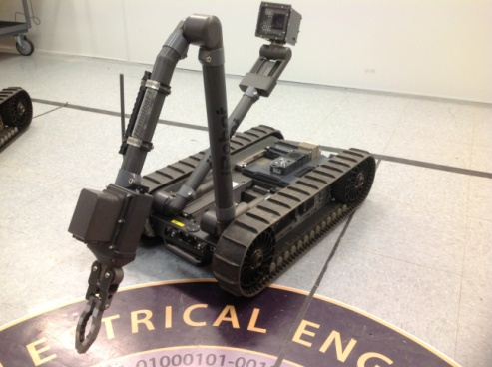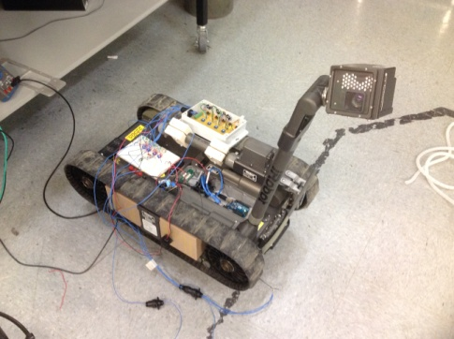

Figure 7: Plain PackBot chassis Figure 8: Sensor testing with PackBot

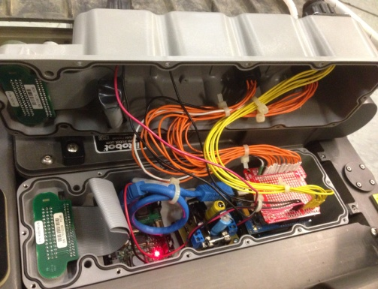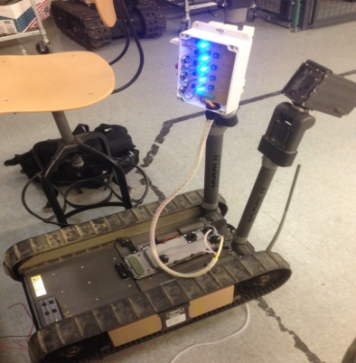

Figure 9: Complete paybreak housing and wiring Figure 10: Functional prototype

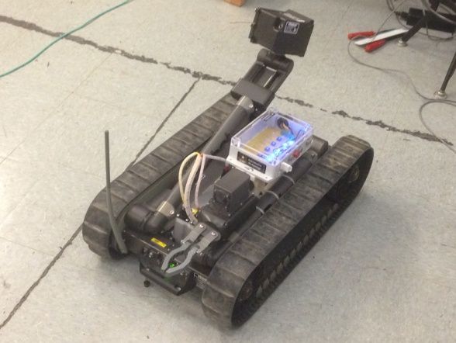

Figure 11: Final model with complete sensor package



Figure 12: ARIBO-IH group after a successful Projects Day

**Recommendations for Future Work**

This year’s focus was a proof of concept for the project. The focus was interfacing the new hardware with the PackBot system. There are 4 areas in which we could improve. First, the sensors we used in our system were selected because they were on hand, inexpensive units. The accuracy of the sensor units is suspect because of the construction of the sensor makes the sensor reactive to all molecules within a certain range of sizes. The sensors also needed power for about 5 minutes to become reactive to any gas input. The temperature and humidity sensor was acceptable in all areas of operation, however, it lagged by 2 to 4 seconds from the addition of a heat source to the sensor outputting a signal noting that change. Using better sensors will help the project’s accuracy. Our group was unable to test the accurate operation of sensors with the completed system. We were able to expose gas to the sensors and get them to react, proving the system worked. However, we were unable to calibrate the competed system because we lacked a chamber to house the completed project. We calibrated the sensors; however, the full system may have changed their output in the full system. Fully calibrating the final system with a total system test would ensure its accuracy. Future groups working on improving the project will definitely want to consider using higher quality sensors that do not require extensive testing and calibration before integration. These sensors will be more expensive, but easier to work with which will be helpful since the plug-and-play aspect will be the focus of future work.

Second, the communications system used in the prototype is restricted to line of sight. Incorporating a new communications subsystem that would allow for greater range and allow communications with the PackBot around corners would improve the project’s range and functional ability.

Third, the GUI used in our final system worked for our specific sensor package. Changing the software where the system detects which package is attached to the PackBot and automatically changes the display would improve the system.

Finally, it would be beneficial to consider adding two components to the outside of the paybreak housing. Adding a USB connector to the outside that is always connected to the Arduino internally would make it easier to upload new code to the microcontroller without having to disassemble the housing every time. Furthermore, using the I/O board to connect a reset switch to the outside of the housing for the Arduino would make it easier to debug certain connectivity issues that we were only able to solve through resetting the Arduino.

**Conclusion**

Overall, all project specifications were met. The interface requirement consisted of connecting a gas sensor package to a microcontroller via an Ethernet connection, connecting the microcontroller to the Packbot via 40 pin ribbon cable provided with the PackBot, and connecting the PackBot to the OCU via 4.9 GHz radio; this specification was met. The functional requirements were to create a sensor package that could interface with the PackBot and to create a data capture system that could capture and record sensor data. Although the sensors were not accurate and required serious adjustments, they were able to measure the gas concentrations in an environment, the microcontroller and PayBreak were able to collect and package the data, and the OCU was able to receive this data via the 4.9 GHz radio. Finally, the performance requirements for the ARIBO-IH were for the robot to detect several hazards to human health, to be able to operate in an indoor environment, to operate with sensors up to 2 hours without replacing batteries, and to be water-resistant for moist environments and decontamination. All requirements for this specification were met through indoor testing. With all specifications met and the final product well-packaged and documented, the project as a whole was very successful and ready to be handed off to next year’s group.

**Works Cited**

"BA 5590 Lithium Military Battery." *BA 5590 Lithium Military Battery*. Defense Update, n.d. Web. 09 May 2014.

"Carbon Monoxide Sensor - MQ-7." *- SEN-09403*. Sparkfun Electronics, n.d. Web. 09 May 2014.

"Hydrogen Gas Sensor - MQ-8." *- SEN-10916*. Sparkfun Electronics, n.d. Web. 09 May 2014.

"LPG Gas Sensor - MQ-6." *- SEN-09405*. Sparkfun Electronics, n.d. Web. 09 May 2014.

"Methane Gas Sensor - MQ-4." *- SEN-09404*. Sparkfun Electronics, n.d. Web. 09 May 2014.

“iRobot’s 510 PackBot CBRNe”. PDF. 2013 iRobot Corportation.

**Annex 1: Quad Chart**



**Annex 2: Social, Political, and Economic Considerations**

***Social***

The ARIBO-IH sensor package will have the same social reactions on both the civil and military sectors that the PackBot does. The sensor package is attached to the PackBot chassis and has a similar function: keeping a human out of danger. The PackBot is designed to be operated by a human operator from a laptop close, but a safe distance from where the robot is operating. iRobot sells a chemical detector package with the same purposes as our sensor package. Because this is not the fist hazardous materials detector offered for the PackBot, there would be no technological impact from the design.

The ARIBO-IH sensor package is designed to place the robot in an area that potentially has some chemical contamination and determine if the area is safe for humans. The design will keep humans out of potentially dangerous situations. This is a well accepted use for robots and will not make any cultural impacts. Furthermore, the robot must be controlled by a human operator in order to function. Autonomous robots are not socially accepted universally and the design we implement avoids this controversy. One of the costs for failure of the design is the same as for a basic PackBot, a human must expose him or herself to a potentially dangerous situation. If the design does not read a dangerous situation as dangerous, humans might venture into a dangerous area and get hurt as a result. Both of these potential errors are engineering failures and can be mitigated from proper engineering techniques and practices. At best, the design will allow humans another degree of safety from potentially dangerous situations.

***Political***

There are no current laws regulating robots in dangerous situations. The ARIBO-IH sensor package is a human operated robot and there are two entities responsible for the robot’s actions. The human operator is responsible for input given to the robot during operation. The design is simply a tool used by a human so any action done by the robot through human input is the responsibility of the human. The operator is also responsible for the upkeep of the robot. Any error the robot has due to improper use, care, or maintenance is the responsibility of the operator. If the operator does everything correctly and the robot still malfunctions, the engineers who designed the robot are responsible for the failure. The ARIBO-IH sensor package was designed to interface with the PackBot chassis by the cadet engineering team. If a human was hurt because of an engineering failure of the robot, the engineering team responsible for that component would be responsible for that failure. If the injury was caused by improper use or maintenance by the operator of the robot, the operator would be at fault. The ARIBO-IH sensor package is just a tool to improve the safety of humans in a potentially harmful environment.

***Economic***

The cost of the prototype is $75,155. The ARIBO-IH PackBot Chassis from iRobot costs approximately $75,000. The Arduino microcontroller, Ethernet Shield (and Ethernet cable), and Proto Board all together cost approximately $83.00. The sensors used for the ARIBO-IH Sensor Package cost approximately $38.00 in total. This includes the DHT22 Temperature & Humidity Sensor at $12.50, the MQ-8 Hydrogen Sensor at $7.95, the MQ-7 Carbon Monoxide Sensor at $7.25, as well as the MQ-6 LPG Sensor and MQ-4 Methane Sensor both at $4.25 each. The various electrical components including, but not limited to, LEDs, wiring, potentiometers, inductors, capacitors, and resistors cost about $15.00. Finally, the plastic test environment and syringes for each gas sensor cost approximately $17.00. Therefore the total amount that it would cost an individual to replicate the design (assuming there is no need to purchase a PackBot) would be almost $160.00. This amount does not include computer costs since the computer used to modify the software is dependent on the individual.

In the long term, the modular design of these boards will benefit the user because they will be able to purchase different boards with several sensors for various specific applications at around $40.00. Furthermore, they could choose to create their own board with sensors they select to interface with the PackBot. Overall, the current design will allow users to integrate several inexpensive sensor boards and combinations for industrial hygiene missions. The standard communication used between the microcontroller and the PackBot is Ethernet, while the OCU communicates with the PackBot via the 4.9GHz Radio Kit using TSP protocol.

The broader economic implication for brining the prototype to market is an alternative to the chemical detection package offered by iRobot. Our series of packages cam be marketed at a price atleast an order of magnitude less than the iRobot product. With the winding down of the war on terror, PackBots are no longer being used for their original purpose of IED disarming. This project repurposes the PackBots, giving it a new mission.

***Environmental***

The operating environment has an impact on the operation of the prototype. Though designed for an indoor operating environment, the prototype can operate outdoors. The radio signal between the robot and OCU is strictly line of sight, and if a barrier is placed between the two components of the system the robot fails to function. This problem can be mitigated through the use of a different communications system offered by iRobot, however these systems would increase the cost of the project.

The robot can operate in both indoor and outdoor environments. The robot is waterproofed to allow for decontamination after each mission. However, the sensors selected for the project are not meant to be exposed to water. These sensors were selected based on the project budget and availability. A potential problem in the operation of the project is that exposure to water could affect sensor output until water lodged in the sensor is removed.

The robot is powered by Lithium-Ion batteries which have no environmental impact during the operation of the prototype. However, the charging and disposal of the batteries may have an environmental impact. Lithium-Ion batteries contain metals that are harmful to the environment if not disposed of correctly. The charging station for the batteries is powered by a standard 120 V AC wall socket. If the wall socket is not powered by a green energy source than the energy used to charge the battery will have an environmental impact.

**Annex 3: Output Correction Graphs**

Figure 13: Sensor Output (Stable) vs. Gas Concentration for MQ-6 Sensor

Figure 14: Sensor Output (Stable) vs. Gas Concentration for MQ-7 Sensor

Figure 15: Sensor Output (Stable) vs. Gas Concentration for MQ-8 (Hydrogen) Sensor

**Annex 4: Corrected Output Results**

|  |  |  |  |
| --- | --- | --- | --- |
| **Test 2** |  |  |  |
| **Gas Concentration (ppm)** | **Output (Stable)** | **Gas (Actual)** | **Gas (Experimental)** |
| 0 | 87 | 0 |  |
| 500 | 281 | 500 |  |
| 1000 | 361 | 1000 |  |
| 2000 | 453 | 2000 | 2000.588491 |
| 3000 | 512 | 3000 | 2970.532956 |
| 4000 | 555 | 4000 | 3962.366243 |
| 5000 | 592 | 5000 | 5077.105842 |
| 6000 | 619 | 6000 | 6083.87229 |
| 7000 | 641 | 7000 | 7050.097052 |
| 8000 | 661 | 8000 | 8061.030347 |
| 9000 | 677 | 9000 | 8973.191259 |
| 10000 | 690 | 10000 | 9789.803482 |

Table 2: Known gas concentration compared to uncorrected stable output and final output for lethal range of concentration for MQ-6 sensor.

|  |  |  |  |
| --- | --- | --- | --- |
| **Test 1** |  |  |  |
| **Gas Concentration (ppm)** | **Output (Stable)** | **Gas (Actual)** | **Gas (Experimental)** |
| 0 | 170 | 0 |  |
| 200 | 480 | 200 | 202.0804652 |
| 400 | 550 | 400 | 376.7816947 |
| 600 | 605 | 600 | 614.719435 |
| 800 | 638 | 800 | 824.5732341 |
| 1000 | 658 | 1000 | 985.2209793 |
| 1200 | 680 | 1200 | 1198.308143 |
| 1400 | 701 | 1400 | 1444.568529 |
| 1600 | 711 | 1600 | 1579.029916 |
| 1800 | 723 | 1800 | 1757.005047 |
| 2000 | 735 | 2000 | 1955.040055 |

Table 3: Known gas concentration compared to uncorrected stable output and final output for lethal range of concentration for MQ-7 sensor.

|  |  |  |  |
| --- | --- | --- | --- |
| **Test 2** |  |  |  |
| **Gas Concentration (ppm)** | **Output (Stable)** | **Gas (Actual)** | **Gas (Experimental)** |
| 0 | 68 | 0 |  |
| 500 | 560 | 500 |  |
| 1000 | 669 | 1000 |  |
| 2000 | 771 | 2000 |  |
| 3000 | 823 | 3000 |  |
| 4000 | 853 | 4000 | 3611.339388 |
| 5000 | 869 | 5000 | 5053.488138 |
| 6000 | 877 | 6000 | 5977.95613 |
| 7000 | 884 | 7000 | 6924.589174 |
| 8000 | 889 | 8000 | 7691.214668 |
| 9000 | 894 | 9000 | 8542.713738 |
| 10000 | 897 | 10000 | 9098.219411 |

Table 4: Known gas concentration compared to uncorrected stable output and final output for lethal range of concentration for MQ-8 sensor.

**Annex 5: Paybreak Housing Pinout Reference**